[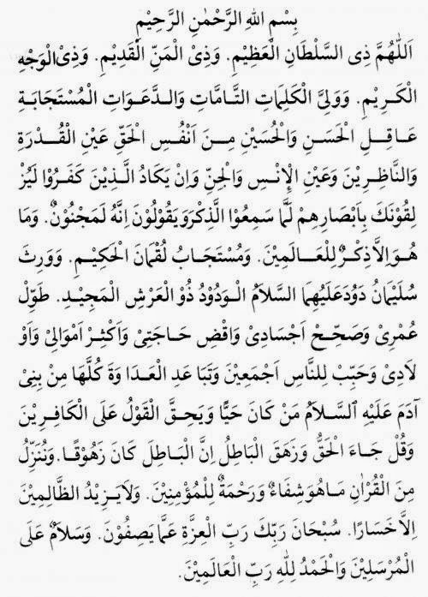](http://2.bp.blogspot.com/-E2FDaZYeD8E/VIsC_7LhG7I/AAAAAAAAEaI/Bv5fr-At6gQ/s1600/doa+nurbuwat.jpg)